LINUX PROGRAMMING: ASSIGNMENT-3: 20-09-2025
Submitted by : Urvija Kapila , 3C , Roll No: 11, ENG24CY0063

- Distinguish between man and whatis commands? Justify with proper example. (CO1)
Ans: Purpose
- man: Displays the complete manual (documentation) of a command, covering usage, options, syntax, description, examples, etc.
- whatis: Shows a one-line description of a command, taken from its man page heading.
Detail Level
- man: Provides detailed information (like a handbook).
- whatis: Provides only a short summary (like a dictionary meaning).
Use Case
- man: Used when you want to learn in-depth about how to use a command and its options.
- whatis: Used when you only want to quickly check what a command does.
Example Output
- Command: man ls
  - Shows a long manual explaining what ls does, its options (-a, -l, etc.), and usage examples.
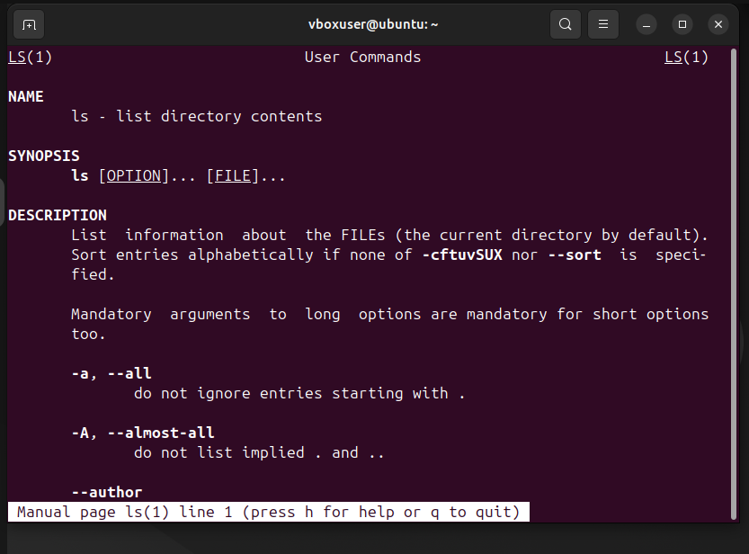

- Command: whatis ls
  - Shows: ls (1) - list directory contents.
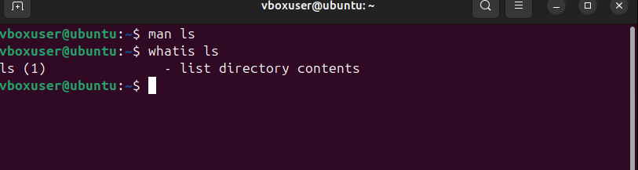 Execution Time
- man: Slower, since it opens a pager (like less) with a full manual.
- whatis: Faster, since it just prints a single line from the database.
Underlying Data
- man: Reads from the manual page files stored on the system.
- whatis: Reads from the whatis database (created with makewhatis or mandb).

- Use the tee command to save the output of ls -l into a file while also displaying it. (CO4)
Ans: The tee command is used to save the output of a command into a file while also displaying it on the terminal.
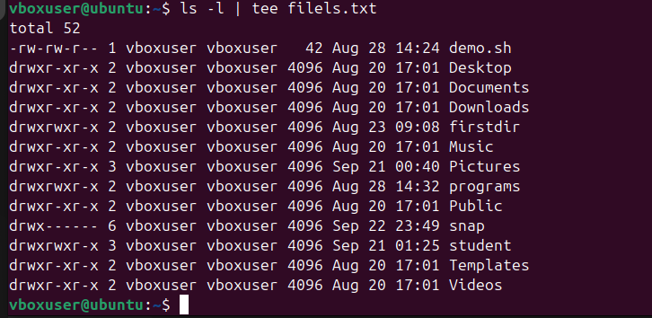
- Explain with an example how the tee command can be used in logging. (CO4)
Ans : The tee command in Linux is a powerful tool for logging because it lets you both display output on the screen and redirect it to a file simultaneously.
For example, you're running a script called install_packages.sh that installs several software packages and you want to monitor its progress on your terminal while also saving all the output to a log file named install.log.

- List the steps involved in installing Ubuntu 25.04 LTS on Oracle VirtualBox. (CO2)
Ans: 1. Download Required Software
  - Install Oracle VM VirtualBox from https://www.virtualbox.org.
  - Download the Ubuntu 25.04 LTS ISO from the official Ubuntu website.
- Create a New Virtual Machine (VM)
  - Open VirtualBox → Click New.
  - Enter name (e.g., Ubuntu 25.04 LTS).
  - Choose Type: Linux and Version: Ubuntu (64-bit).
  - Click Next.
- Allocate Memory (RAM)
  - Recommended: 4 GB (4096 MB) or more (if your system allows).
  - Minimum: 2 GB (2048 MB).
- Create a Virtual Hard Disk
  - Choose Create a virtual hard disk now.
  - Disk type: VDI (VirtualBox Disk Image).
  - Storage: Dynamically allocated (grows as needed).
  - Size: At least 25 GB, recommended 40–50 GB.
- Mount Ubuntu ISO
  - Select the VM → Click Settings → Go to Storage.
  - Under Controller: IDE, click the empty disk icon.
  - Choose “Optical Drive” → “Choose a disk file”.
  - Select the downloaded Ubuntu 25.04 ISO.
- Adjust System Settings (Optional but Recommended)
  - Processor: Increase to 2 or more CPUs (if available).
  - Display → Video Memory: Set to 128 MB and enable 3D Acceleration.
  - Network: Keep NAT (default) or set to Bridged for direct network access.
- Start the Virtual Machine
  - Click Start.
  - The VM will boot from the mounted ISO.
  - Choose Try or Install Ubuntu.
- Install Ubuntu 25.04 LTS
  - Select Install Ubuntu.
  - Choose language, keyboard layout.
  - Select Normal Installation (includes GUI, browser, office tools).
  - Choose Erase disk and install Ubuntu (only affects the virtual disk, not your actual PC).
  - Follow prompts to set username, password, and time zone.
- Complete Installation
  - The installer will copy files and install Ubuntu.
  - Once finished, it will ask to Restart.
  - Remove the ISO (VirtualBox usually does this automatically) → Press Enter.

- During Ubuntu OS installation, you face a Kernel Panic Error. How would you troubleshoot it? (CO3)
Ans: A kernel panic during Ubuntu installation means the core of the operating system has encountered a fatal, unrecoverable error. It's often caused by hardware incompatibility, a corrupted installer, or incorrect BIOS/firmware settings. We can troubleshoot this issue by:
1. Check your Installation Media
The most common cause is a corrupted ISO file or a bad USB drive.
- Re-download the ISO: Download the Ubuntu .iso file again, and verify its integrity using the checksum provided on the official Ubuntu website.
- Re-create the USB installer: Use a reliable tool like Rufus (on Windows) or balenaEtcher (on all platforms) to write the ISO to your USB drive. This ensures the installer is created correctly.
2. Check your Hardware
Faulty hardware can lead to errors that the kernel can't handle.
- Test your RAM: Run a memory test (MemTest86 is a popular option) to check for errors in your computer's RAM. A single bad memory stick can cause a kernel panic.
- Unplug external devices: Disconnect all unnecessary USB devices, printers, and other peripherals. Sometimes, a driver conflict with a connected device can trigger a panic.
- Check the hard drive: Ensure your hard drive is properly connected and functioning. A failing disk can cause I/O errors that lead to a kernel panic
4. Adjust Virtual Machine Settings (VirtualBox Specific)
If you're installing on a virtual machine, the error might be in the VM's configuration.
- Increase RAM and CPU cores: A kernel panic can occur if the VM doesn't have enough resources. Allocate at least 4 GB of RAM and 2 CPU cores to the virtual machine.

- Write the command to display the system’s hostname? How to change hostname using sysctl command? (CO1)
Ans: To display the hostname we can use the command ‘hostname’.
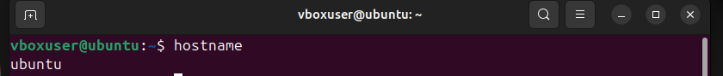
We can change the hostname using the sysctl in the following way-

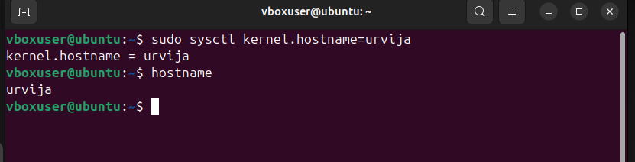
- Which command is used to show the calendar of the year 1984 with August month? (CO1)
Ans:
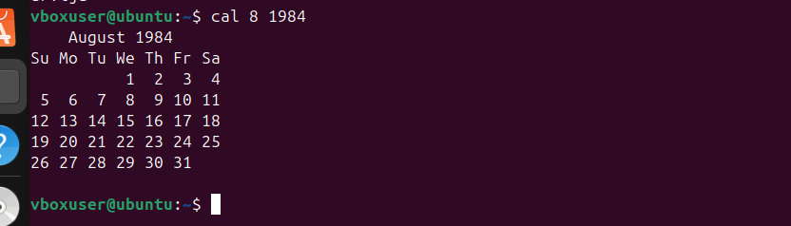
- Write a command to display system uptime and logged-in users together. (CO3)
Ans: we can use w as a direct command to get this information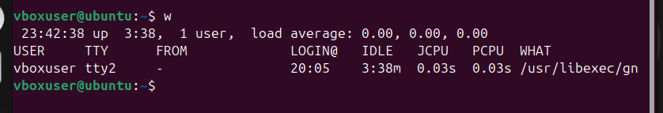
Here up 3:38 is the system uptime and there is only one logged In user.
We can also use the commands separately like this:
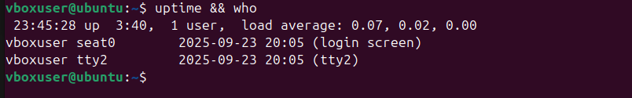
- Use the find command to list all “.c” files in /home/user. (CO1)
Ans: We can use the command- find /home/user -name "*.c"

- How do you change file permissions to allow only the owner to read and write? (CO1)
Ans: We can change the file permissions to allow only the owner to read and write by using the command chmod 600 filename.
Here chmod → Used to change file permissions.
600 → Sets permissions so that:
- Owner → Read (4) + Write (2) = 6
- Group → No permission (0)
- Others → No permission (0)

